**Riphah International University**



**Alisha Ishrat**

**40851**

**CS-6**

**Lab#3**

**07/03/2024**

**Lab Task 1:**

Create Main book directory

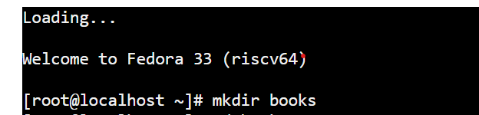

Now, inside of book directory create three more directory Maths, Physics and Computer

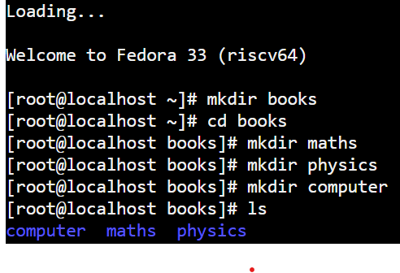

In side of maths books directory create two more directories Trigonometry and Calculus.

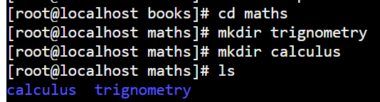

In side of physics directory create three more directories quantum, classical and nuclear.

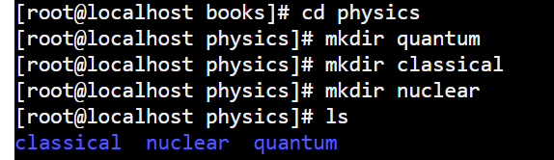

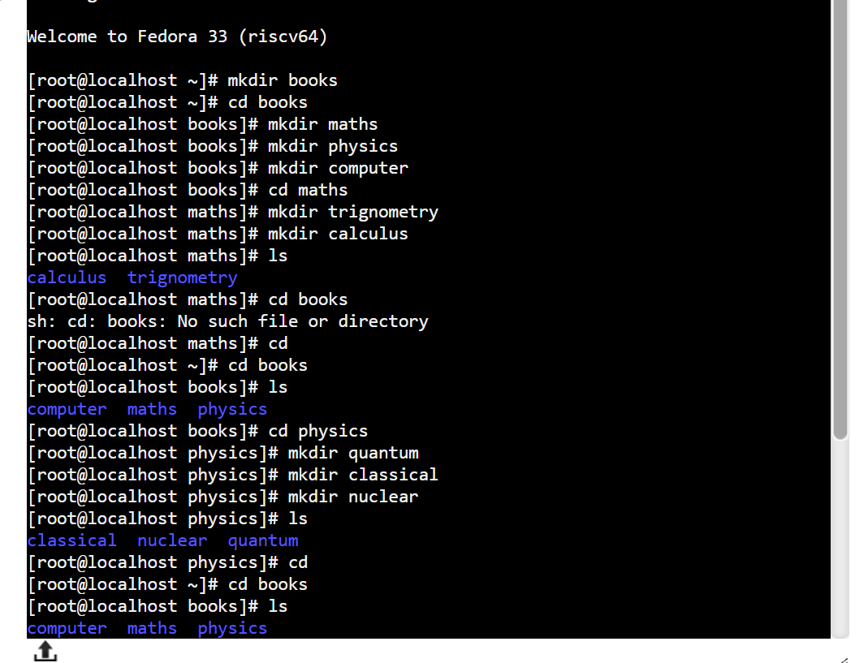

**Lab Task 2:**

**What are Linux Directory Commands? Explain the understanding of commands in your own words. Also define what is BASH?**

Linux commands are used to interact with the operating system and perform various tasks. Linux directory commands are used to navigate, create, delete and manage directories in the file system through terminal. The commands offer a lot of flexibility in terms of displaying the data in the output. Here are some commonly used directories:

* pwd: Display the full path of the current directory.
* ls: Show the files and directories in the current directory.
* cd: Moves from one directory to another.
* mkdir: Creates a new directory.
* rmdir: Deletes a directory.
* touch: Create an empty file.

**BASH:**

BASH stands for Bourne Again Shell. It is the most commonly used shell in operating system. It provides the way to interact with the system by typing commands and receiving output. It is like a translator that helps you communicate with your computer using commands. When you type a command, BASH understands it and performs actions on it.

**Lab Task 3:**

Creating the main Directory

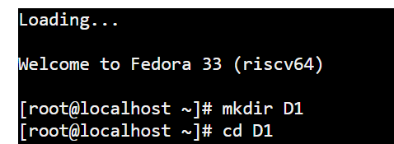

Now, creating the sub-directories into main directory.

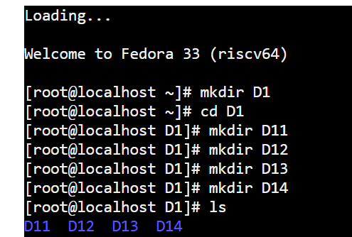

Now, creating files into directories.

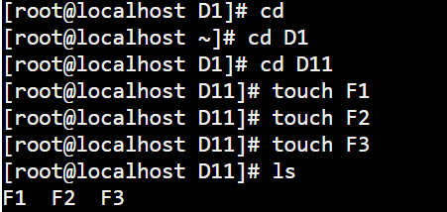

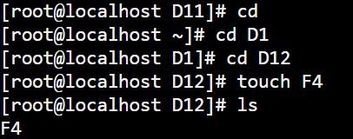

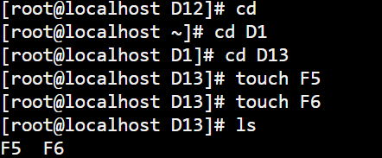

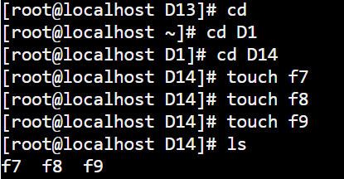

**Lab Task 4:**

Creating main directory

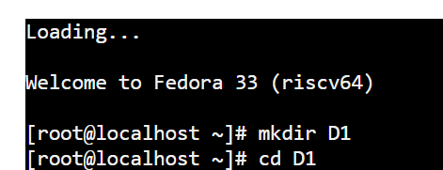

Now, creating four more sub-directories into main directory.

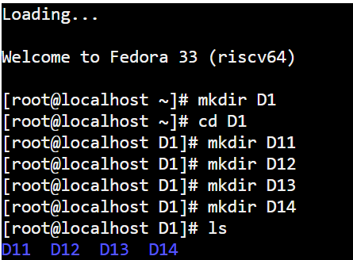

Now, creating files into sub-directories.

* Creation of two files **F1, F2** into **D11** directory.

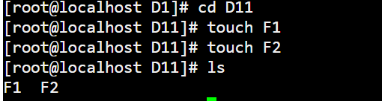

* Creation of one files **F3** into **D12** directory.

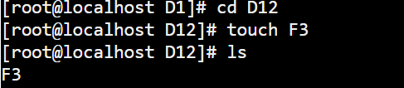

* Creation of two files **F4, F5** into **D13** directory.

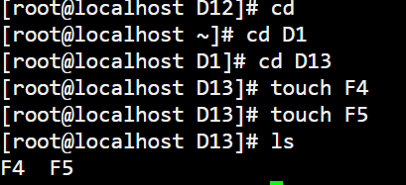

* Creation of one file into D14 directory.

